<https://linuxize.com/post/how-to-install-apache-maven-on-ubuntu-20-04/>

<https://www.vogella.com/tutorials/ApacheMaven/article.html>

<https://javakeypoint.wordpress.com/2020/08/18/difference-between-mvn-clean-package-and-mvn-clean-install/>

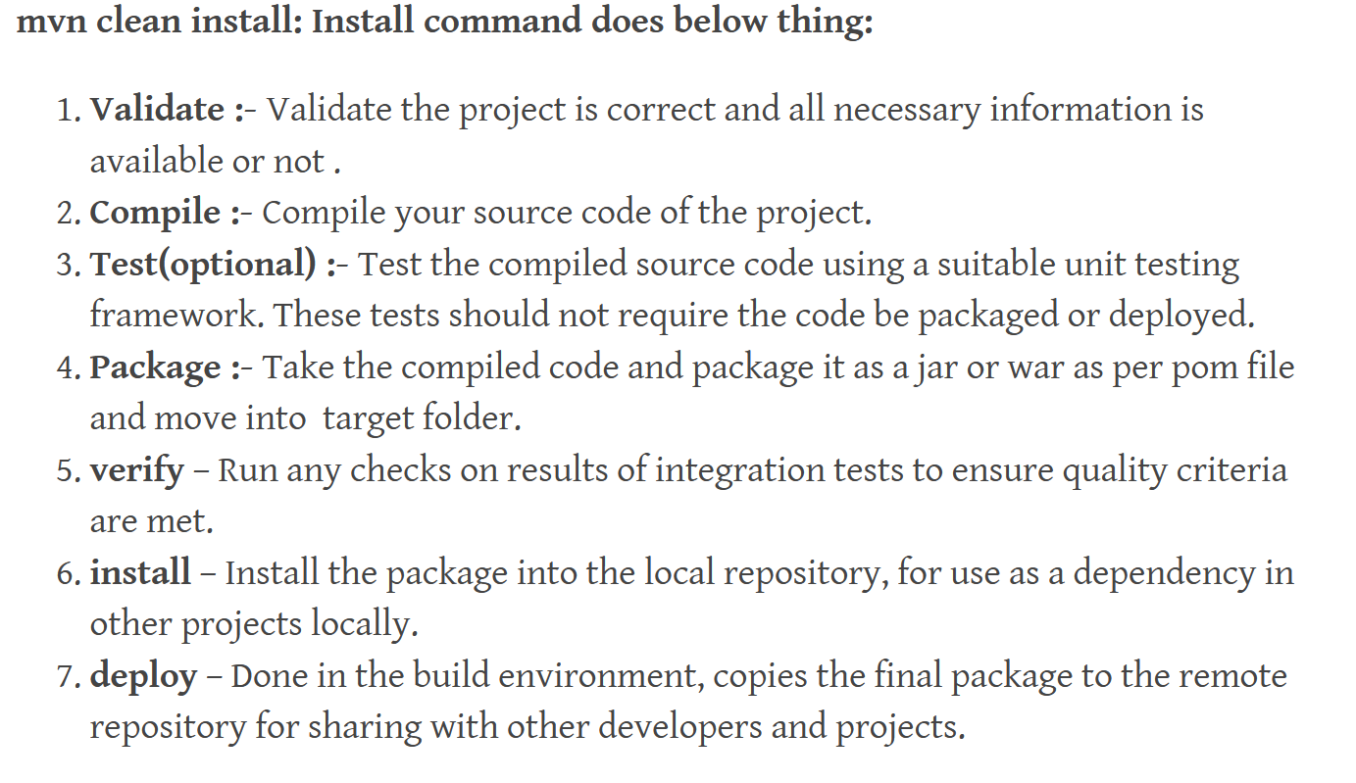

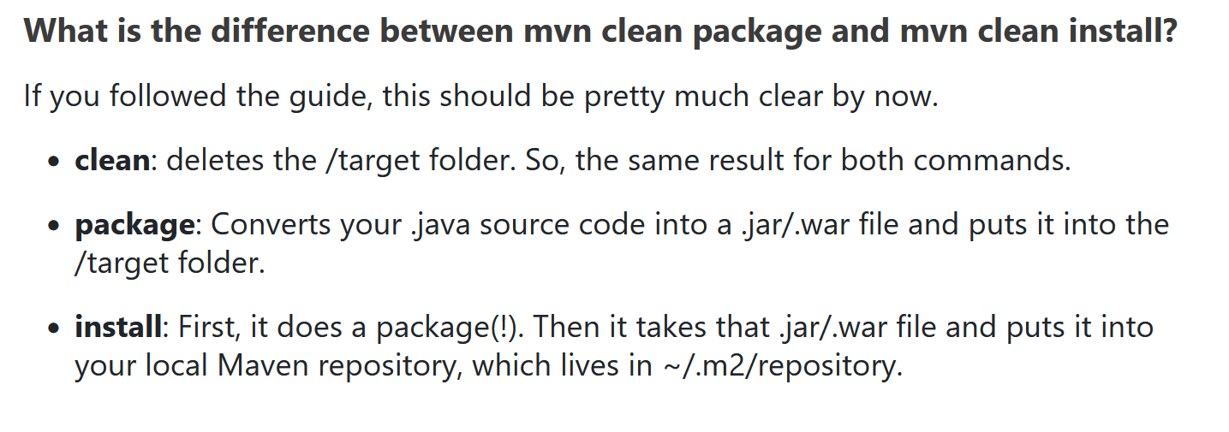

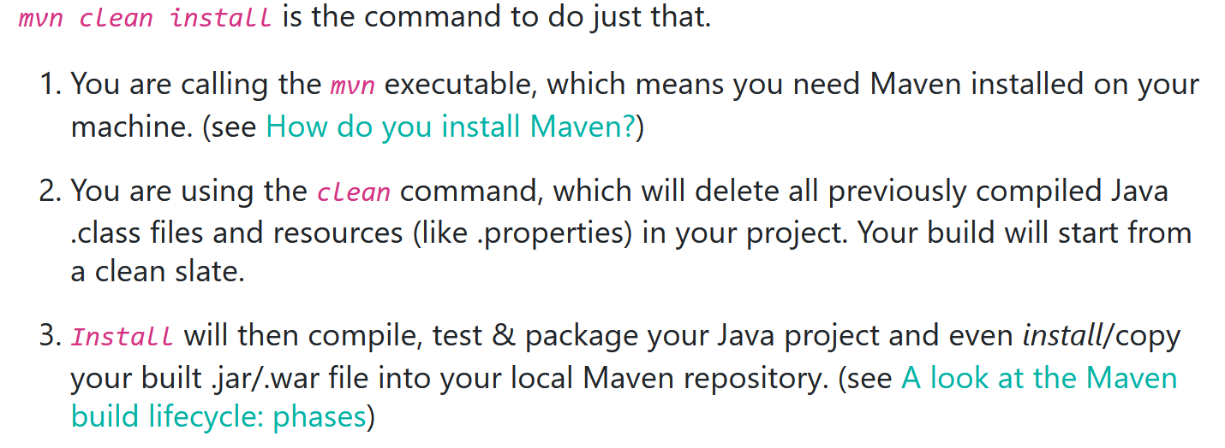

<https://github.com/spring-projects/spring-petclinic>

Good videos on Maven: <https://www.youtube.com/watch?v=Xatr8AZLOsE>

For maven dependencies: <https://search.maven.org/>

<https://springframework.guru/spring-profiles/>

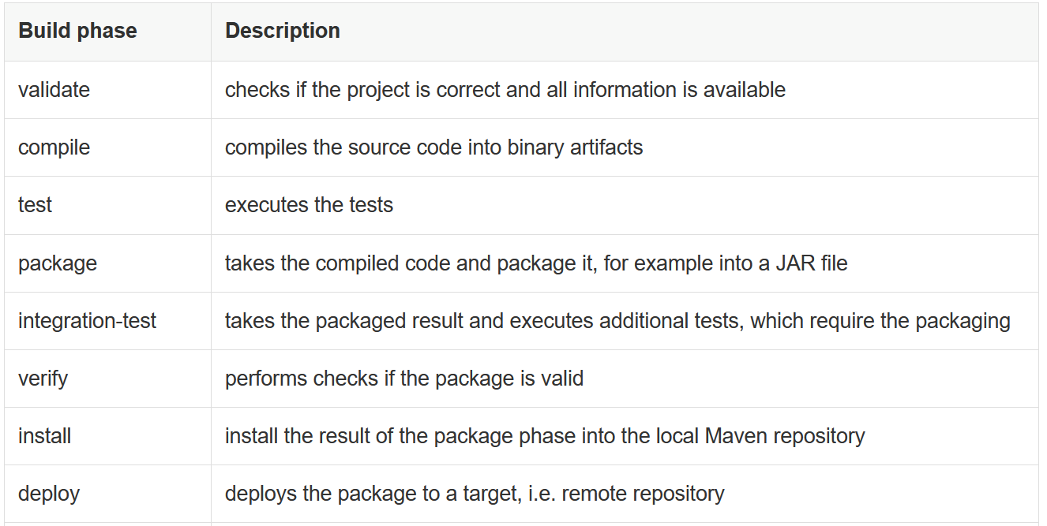

Use below step:

cd /opt

wget https://dlcdn.apache.org/maven/maven-3/3.8.4/binaries/apache-maven-3.8.4-bin.tar.gz

tar xzvf apache-maven-3.8.4-bin.tar.gz

mv apache-maven-3.8.4-bin.tar.gz maven

echo 'export M2_HOME=/opt/maven' >> ~/.bashrc

echo 'export PATH=${M2_HOME}/bin:${PATH}' >> ~/.bashrc

source ~/.bashrc

mvn –version

git clone https://github.com/jenkins-docs/simple-java-maven-app.git

mvn validate

mvn compile

mvn test

mvn package

java -jar /root/simple-java-maven-app/target/my-app-1.0-SNAPSHOT.jar

nano /root/simple-java-maven-app/src/main/java/com/mycompany/app/App.java #Add Custom data

nano /root/simple-java-maven-app/src/test/java/com/mycompany/app/AppTest.java #Add Custom data.

mvn clean

mvn clean compile

mvn clean compile test package

mvn clean compile test package verify

mvn clean compile test package verify install

mvn clean compile test package verify install deploy

mvn package -Dmaven.test.skip=true